**EAST WEST UINVERSITY**

**Department of Computer Science and Engineering**

**Post Lab**

**Semester:** Summer’17

**Course code:** CSE 251 (2)

**Course title:** Electronic Circuits

**Experiment No:** 01

**Experiment title:** I-V Characteristics and Modeling of Forward Conduction of a Diode

**Submitted to:**

Surajit Das Barman

Senior Lecturer

Department of CSE

East West University

**Submitted by:**

Kowser Mahmud Tanim

ID: 2015-2-60-062

Group No: 05

Group IDs: 2015-2-60-078, 2015-2-60-057,2015-2-60-108

**Date of performance:** 16/05/2017

**Date of report submission:** 30/05/2017

**Experiment No:** 01

**Experiment title:** I-V Characteristics and Modeling of Forward Conduction of a Diode

**Objectives**

1. To measure the I-V characteristics of forward conduction of a p-n junction diode.

2. To determine the models of forward conduction of a p-n junction diode.

**Circuit diagram**



**Figure:** Circuit set up to measure forward bias I-V characteristics of a diode

**Equipments and Components used**

1. DC power supply
2. Digital multimeter
3. Diode (1 pc)
4. Resistor 1KΩ
5. Breadboard
6. Connecting wires
7. Matlab
8. Pspice

**Question Answers**

**1.**

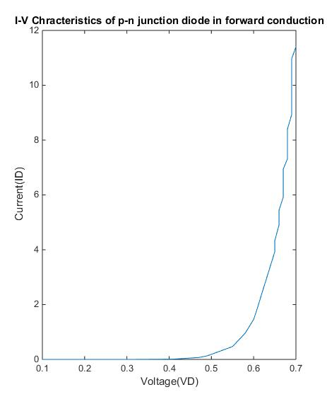

**2.**

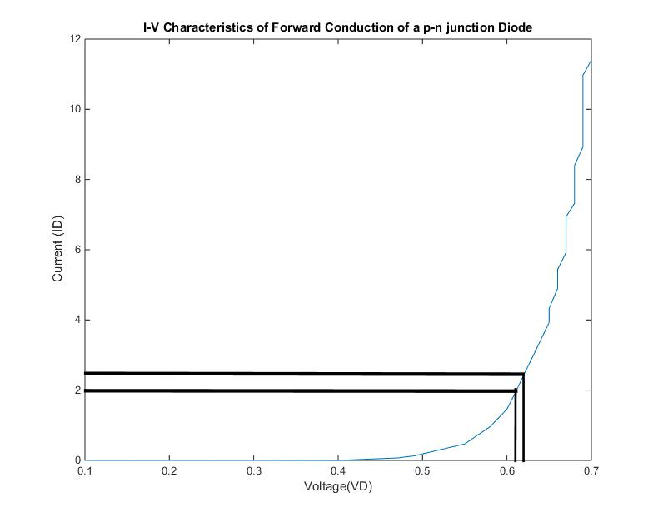

Here I1=2.5, I2=2,VD1=0.62 and VD2=0.61

We know, VD1-VD2=nVtln(I1/I2)

So, n = 1.73

We also know, ID1= ISexp[VD1/nVT]

=>IS=ID1/exp[VD1/nVT]

=>IS=2*10-3/exp[0.62/1.73*0.0259]

=>IS = 0.00174A

**3.** Cut in voltage from the printed graph

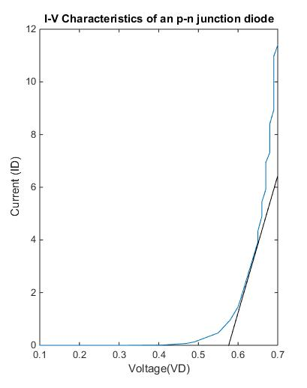

From above graph cut in voltage is 0.58.

**4.** Calculated value $r_{D}$ from the data using the equation

1/ $r_{D}$ = (ID2- ID1)/( VD2- VD1)

ID1 = 2.5 mA and VD1 = 0.62 V

And for ID2 = 2.0 mA and VD2 = 0.61 V

So, the value of $r_{D}$ = 0.05 k ohm

**5.**

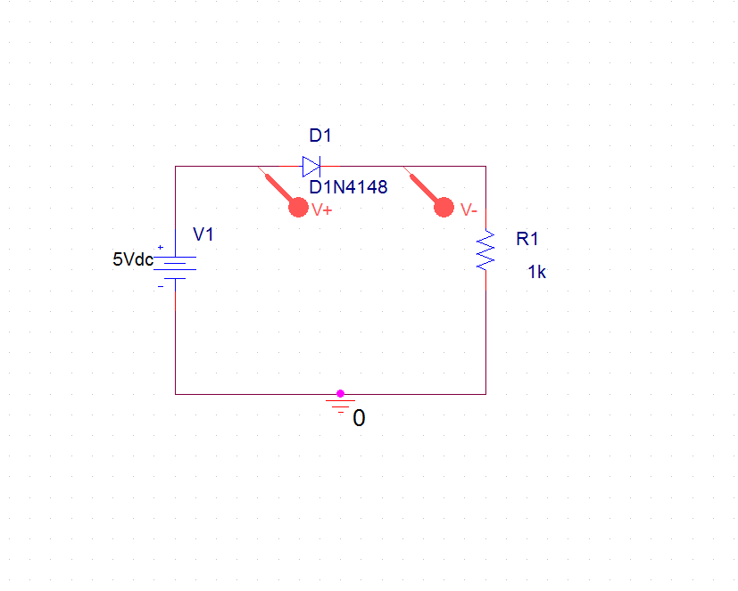

Fig 4: DC bias (VS) range of 0-5 volts using PSpice.

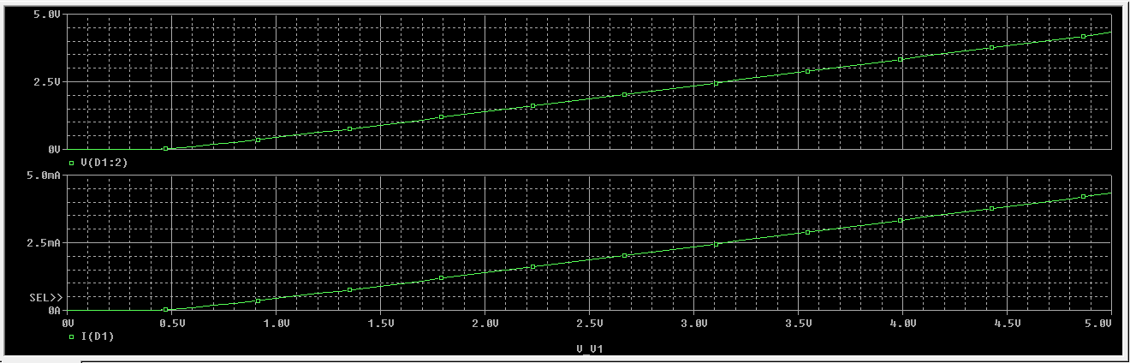

**Conclusion**

After this experiment, I have learn how to Calculate the diode parameters $I_{S}$, how to determine cut – in voltage from the printed graph and how to determine $r_{D}$.